**BitLocker Drive Encryption**

The City of Niles IS Staff is in the process of enabling BitLocker on all workstations. BitLocker allows us the protect our data from loss, theft, and during workstation decommissioning.

You will soon receive a popup message on your workstation informing you that BitLocker drive encryption is required. Please click **Start** when you receive this message, be sure not to click Postpone.

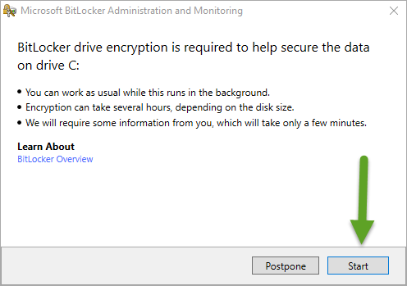

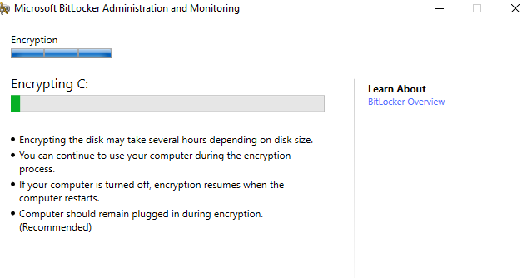

Encryption will take approximately 20 minutes to complete. You can continue to work during this process.

Click **Close** when complete

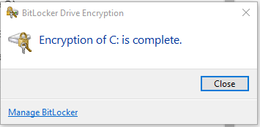

Please contact the Helpdesk if you have any questions or concerns.

Thank you,

City of Niles IS Staff.